WEST YORKSHIRE FIRE & RESCUE SERVICE

JOB DESCRIPTION

POST TITLE: | Fire Protection Administrator
GRADE: | Grade 2
RESPONSIBLE TO: | Senior Fire Protection Administrator
PURPOSE OF POST: | To undertake administration and word processing tasks, including the maintenance of associated database records. To carry out the duties of the Senior Fire Protection Administrator as necessary in the post holder’s absence.
ORGANISATIONAL CHART
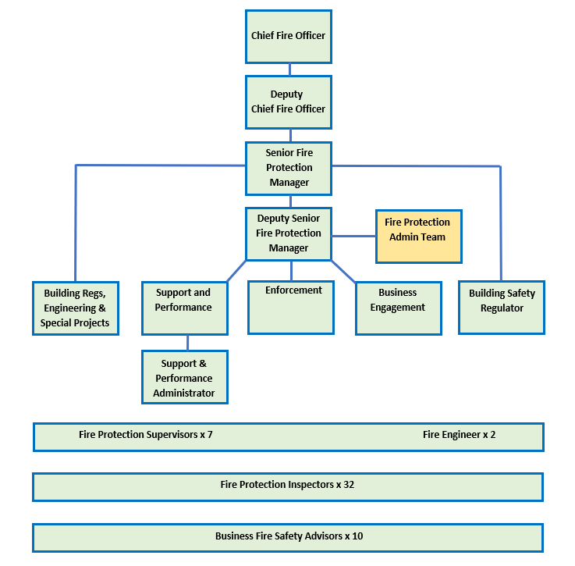

MAIN DUTIES AND RESPONSIBILITIES OF THE ROLE

- Provide comprehensive administrative support for the Fire Protection Team including dealing with routine emails, post, calls and reviewing documents and forms as necessary.
- To type letters (standard and non-standard), forms, reports and memorandum.
- Maintain manual and electronic filing systems, information and records.
- Deal with advice requests from members of the public transferring such request to appropriately qualified Officers where necessary.
- Peruse/ scan and distribute all incoming mail and arrange signature and despatch of outgoing mail.
- Day-to-day control of the Fire Protection budgets, maintaining computerised records of expenditure for supplies, equipment and the office inventory.
- Attend Fire Safety and other departmental meetings, prepare agendas and take notes and produce minutes when required to do so.
- To be responsible for planning and booking resources; including diarising appointments, ICT access/arrangements and team meetings.
- Prepare agendas and take minutes for team and departmental meetings, maintain meeting records and monitor action plans as necessary.
- Where necessary, assist with the management and monitoring of the Fire Protection Database, resolving minor related database queries and update with acknowledgements, special considerations, and primary authority schemes.
- Provide basic training in the use of the Fire Protection Database and assist users with entering data where necessary.
- Support the Petroleum & Explosives Administrator by assisting with the licensing and certification processes around the storage of Petrol and Fireworks.
- To support with the testing of development work and changes to the Fire Protection database.
- Assist with Freedom of Information and data gathering requests.
- Assist with updating and uploading the National Enforcement Register.
- Receive and appropriately deal with requests from members of the public, external agencies, and internal departments, including accurately entering data on the Fire Protection Database.

ORGANISATIONAL WIDE RESPONSBILITIES:

- Adherence to the Core Code which sets out five ethical principles, based on the Seven Principles of Public Life.


- To Implement and promote the Authority’s:
- Health and Safety policies.
- Equality and Diversity policies.
- Information Security Management System policies.
- Safeguarding policies.
- Business continuity policy and contingency arrangements.
- Policies related to General Data Protection Regulation and Data Protection Act 2018.
- Commitment to maintaining our Customer Service expectations.

SKILLS AND EXPERIENCE REQUIREMENTS FOR THIS ROLE.

In the supporting statement section of the application form give clear, concise examples of how you meet all of the Essential person specification criteria (i.e. items you must be able to do from day one to be able to do the job), identified as ‘Application’ in order to be shortlisted for this vacancy. If a large number of applications are received, only those who also meet the Desirable criteria, identified as ‘Application,’ will be shortlisted, i.e., criteria you need to do the job, but which could be learnt during training.

Please list or number the competency criteria below against which you are providing evidence/examples in order to structure your supporting statement in a well organised way.

There may be some criteria that are identified through ‘Selection Process’ only. You will only be assessed on these criteria during the selection process and not from your application form, this may involve tests, presentations, interview etc.

 | Experience. | Essential/ Desirable. | Where identified.
 | Experience of word processing systems i.e. Microsoft Word, using keyboard skills | Essential | Application
 | Experience of databases i.e., Microsoft Excel and Access. | Essential | Application
 | Administrative experience. | Essential | Application
 | Experience of financial and administration systems. | Essential | Interview
 | Good understanding of the database used by Fire Protection. | Desirable | Application

 | Education and Training. | Essential/ Desirable | Where identified.
 | Must demonstrate a good standard of education and be both numerate and literate.  - Literacy and Numeracy at Level 2 / GCSE Maths and English Grade C or above OR  - Equivalent qualifications OR  - Equivalent level of literacy and numeracy gained through work experience. | Essential | Application
 | Qualified to RSA/OCR Word-processing Stage 2 or equivalent Word Processing qualification | Desirable | Application

 | Special Knowledge and Skills. | Essential/ Desirable. | Where identified.
 | Ability to work as part of a team. | Essential | Application
 | Ability to work flexibly in relation to the needs of the post. | Essential | Application
 | Ability to work on own initiative, to work under pressure and to meet deadlines with little supervision. | Essential | Application
 | Good organisational and problem-solving skills. | Essential | Application
 | Experience in organising resources and establishing priorities. | Essential | Interview
 | Possession of excellent communication, verbal and written skills. | Essential | Application & Interview
 | Be able to effectively collate, analyse and present information. | Essential | Interview
 | Demonstrate commitment to good data quality within all areas of work. | Essential | Interview
 | Demonstrate an understanding of the importance of equality and diversity to WYFRS as an employer and service provider. | Essential | Application
 | To hold and maintain a current full UK valid car driving licence. | Desirable | Application

Job Description: Last updated: August 2024

